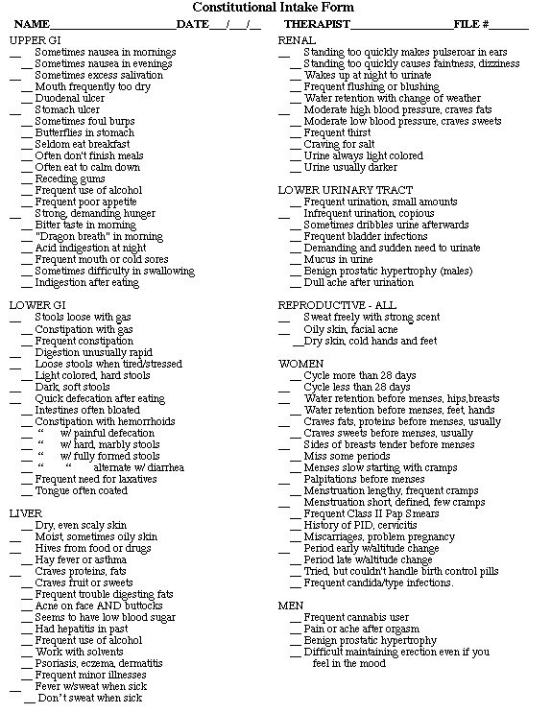

CLIENT, CHECK APPLICATABLE ON FRONT & BACK!
